**ASSIGNMENT NO.2.**

**Aim :-** Construct a threaded binary search tree by inserting values in the given order and traverse it in inorder traversal using threads.

**Program Code:-**

#include <iostream>

using namespace std;

class TBT;

class node

{

node *left,*right;

int data;

bool rbit,lbit;

public:

node()

{

left=NULL;

right=NULL;

rbit=lbit=0;

}

node(int d)

{

left=NULL;

right=NULL;

rbit=lbit=0;

data=d;

}

friend class TBT;

};

class TBT

{

node *root; //acts as a dummy node

public:

TBT() //dummy node initialization

{

root=new node(9999);

root->left=root;

root->rbit=1;

root->lbit=0;

root->right=root;

}

void create();

void insert(int data);

node *inorder_suc(node *);

void inorder_traversal();

node * preorder_suc(node *c);

void preorder_traversal();

};

//--------------------------------------------

void TBT::preorder_traversal()

{

node *c=root->left;

while(c!=root)

{

cout<<" "<<c->data;

c=preorder_suc(c);

}

}

void TBT::inorder_traversal()

{

node *c=root->left;

while(c->lbit==1)

c=c->left;

while(c!=root)

{

cout<<" "<<c->data;

c=inorder_suc(c);

}

}

node* TBT::inorder_suc(node *c)

{

if(c->rbit==0)

return c->right;

else

c=c->right;

while(c->lbit==1)

{

c=c->left;

}

return c;

}

node *TBT::preorder_suc(node *c)

{

if(c->lbit==1)

{

return c->left;

}

while(c->rbit==0)

{

c=c->right;

}

return c->right;

}

//-------- Create Method

void TBT::create()

{

int n;

if(root->left==root&&root->right==root)

{

cout<<"\nEnter number of nodes:";

cin>>n;

for(int i=0;i<n;i++)

{

int info;

cout<<"\nEnter data: ";

cin>>info;

this->insert(info);

}

}

else

{

cout<<"\nTree is Already created.\n";

}

}

void TBT::insert(int data)

{

if(root->left==root&&root->right==root) //no node in tree

{

node *p=new node(data);

p->left=root->left;

p->lbit=root->lbit; //0

p->rbit=0;

p->right=root->right;

root->left=p;

root->lbit=1;

cout<<"\nInserted start"<<data;

return;

}

node *cur=new node;

cur=root->left;

while(1)

{

if(cur->data<data) //insert right

{

node *p=new node(data);

if(cur->rbit==0)

{

p->right=cur->right;

p->rbit=cur->rbit;

p->lbit=0;

p->left=cur;

cur->rbit=1;

cur->right=p;

//cout<<"\nInserted right "<<data;

cout<< data<<" Inserted right"<<" of "<< cur->data<<endl;

return;

}

else

cur=cur->right;

}

if(cur->data>data) //insert left

{

node *p=new node(data);

if(cur->lbit==0)

{

p->left=cur->left;

p->lbit=cur->lbit;

p->rbit=0;

p->right=cur; //successor

cur->lbit=1;

cur->left=p;

cout<<data <<" Inserted left "<<" of "<<cur->data<<endl;

return;

}

else

cur=cur->left;

}

}

}

int main() {

TBT t1;

int value;

int choice;

do

{

cout<<"\n1.Create Tree\n2.Insert into tree\n3.Preorder\n4.Inorder\n0.Exit\nEnter your choice: ";

cin>>choice;

switch(choice)

{

case 1:

t1.create();

break;

case 2:

cout<<"\nEnter Number(data): ";

cin>>value;

t1.insert(value);

break;

case 3:

cout<<"\nPreorder traversal of TBT\n";

t1.preorder_traversal();

break;

case 4:

cout<<"\nInoder Traversal of TBT\n";

t1.inorder_traversal();

break;

default:

cout<<"\nWrong choice";

}

}while(choice!=0);

return 0;

}

**Output Screenshots:-**

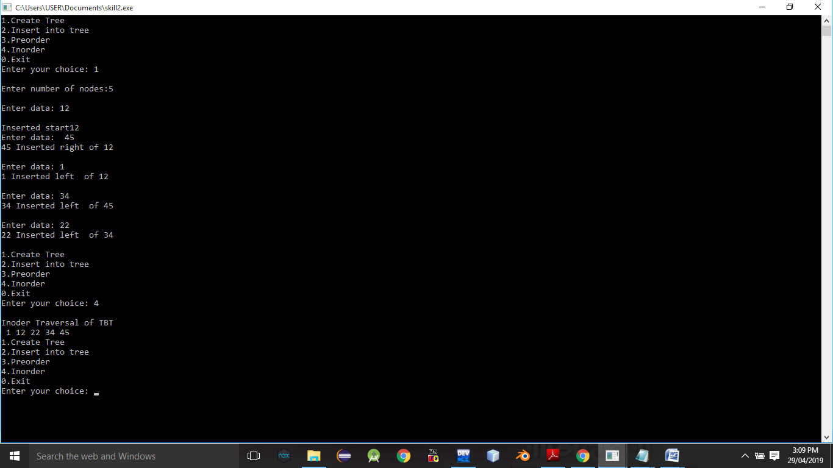

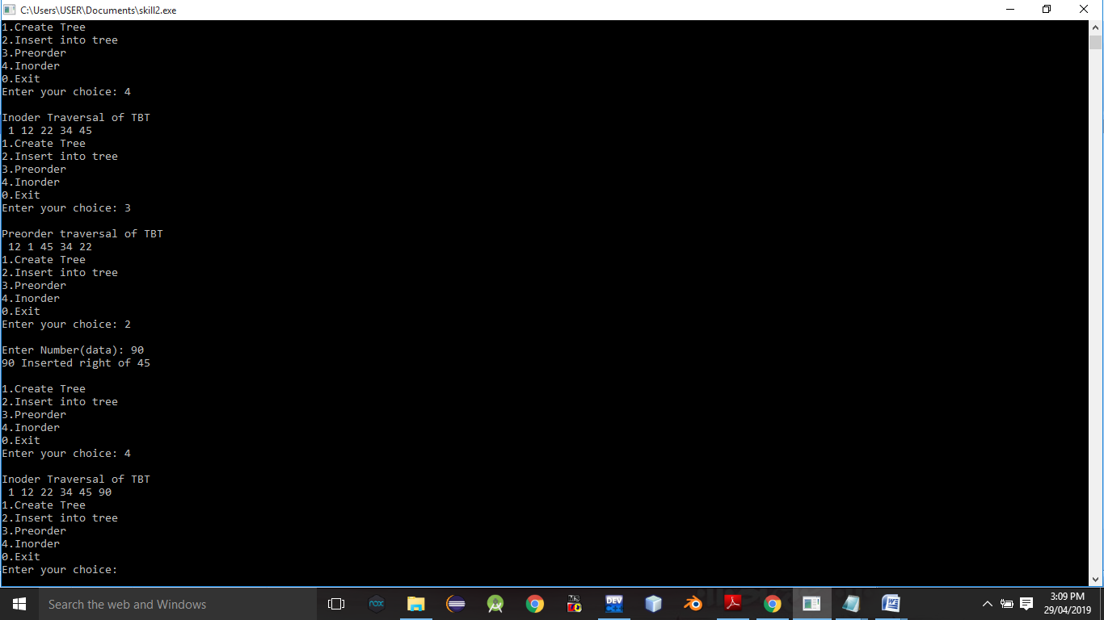

**Conclusion:-** Thus,we have studied Threaded binary tree.